LINUX TASK 1 creat user name with techie and provide sudo accessto user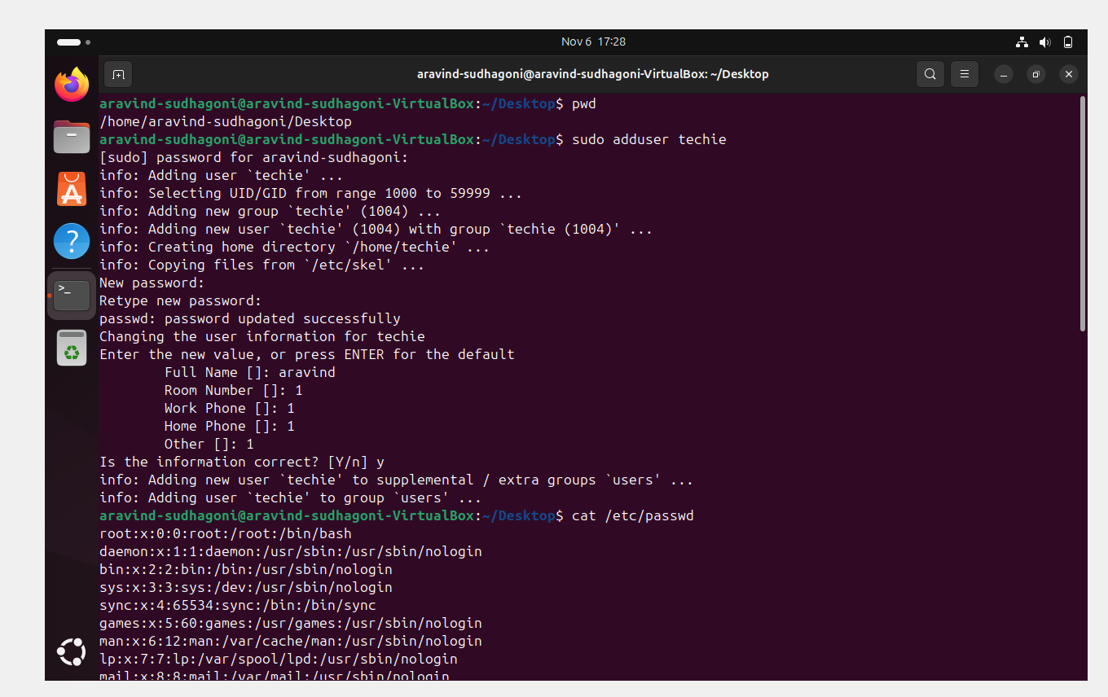

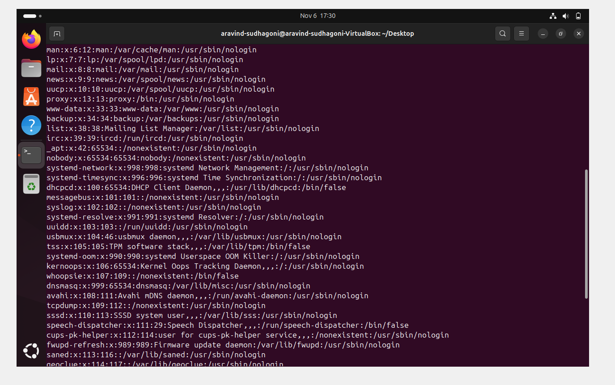

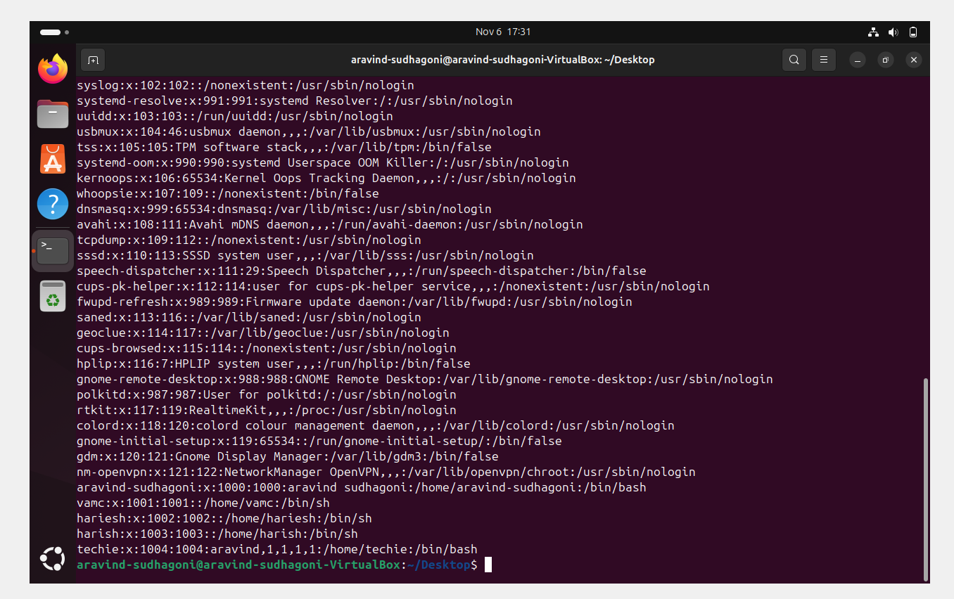

TASK 2 Navigate to the home Directory

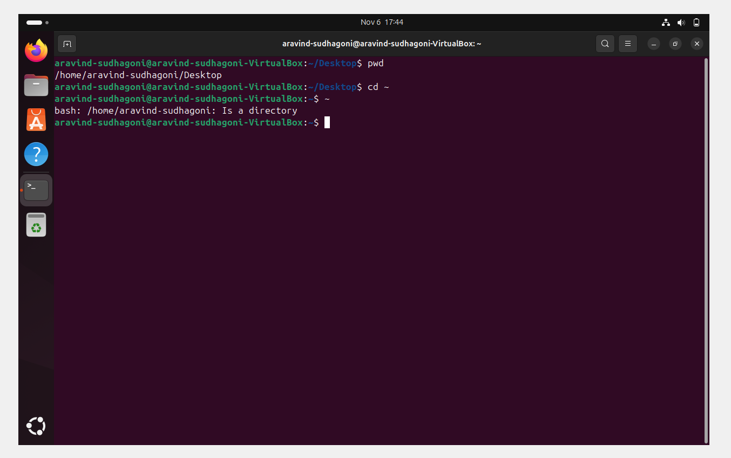

Task 3 Create a new Directory

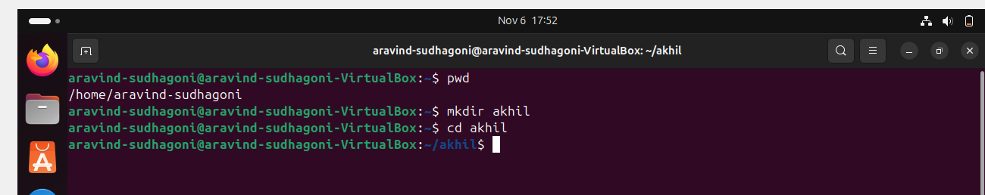

Task 4 List the contents of a directory

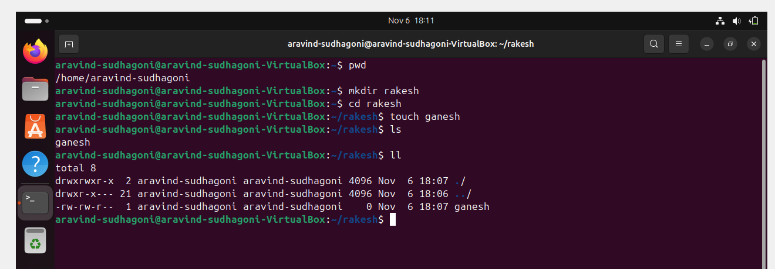

Task 5 change the current directory

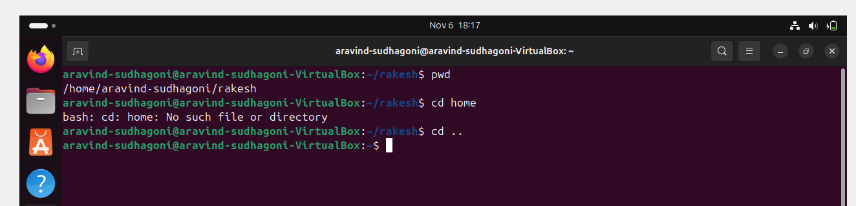

Task 6 create a new empty file

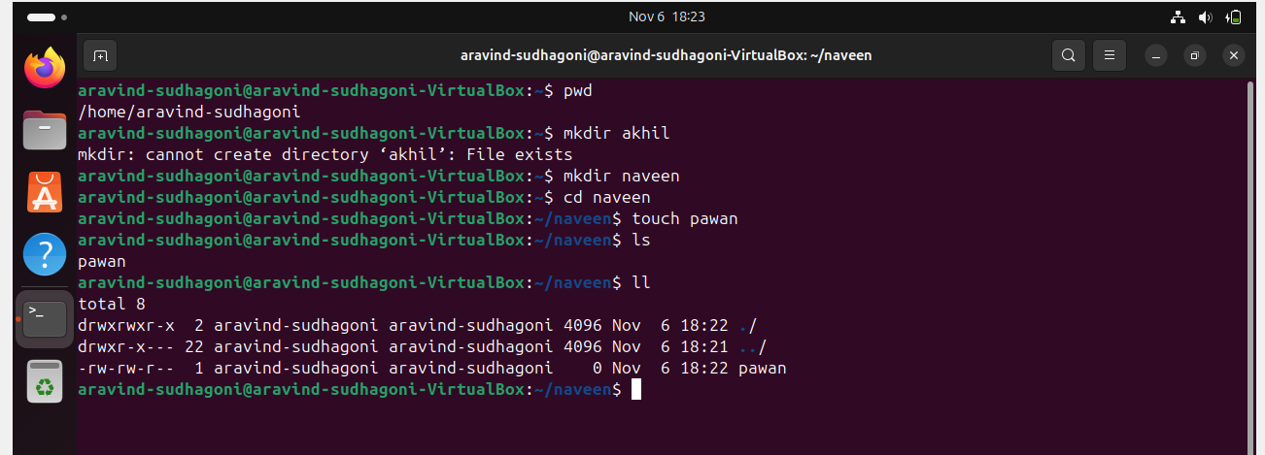

Task 7 view the contents of a file

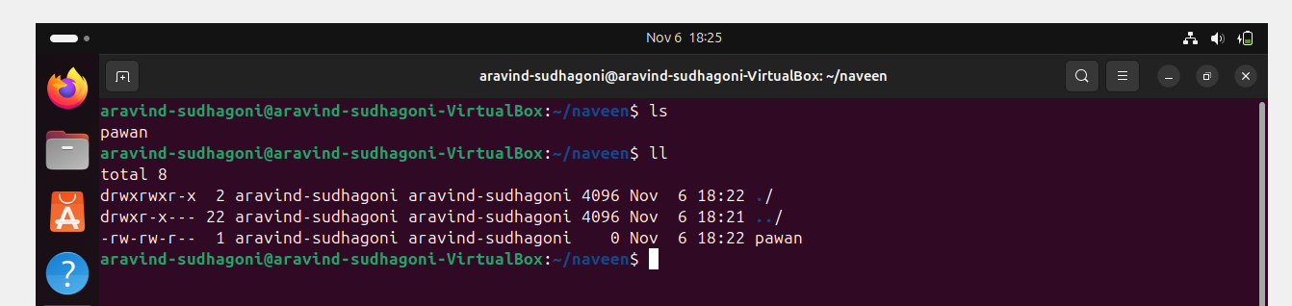

Task 8 copy a file to another location

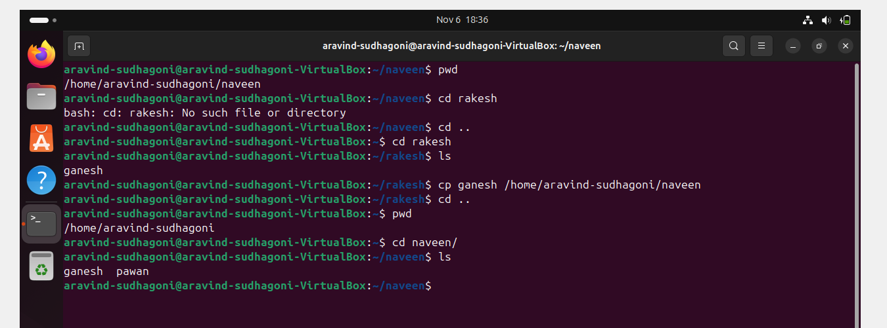

Task 9 Move a file to another location

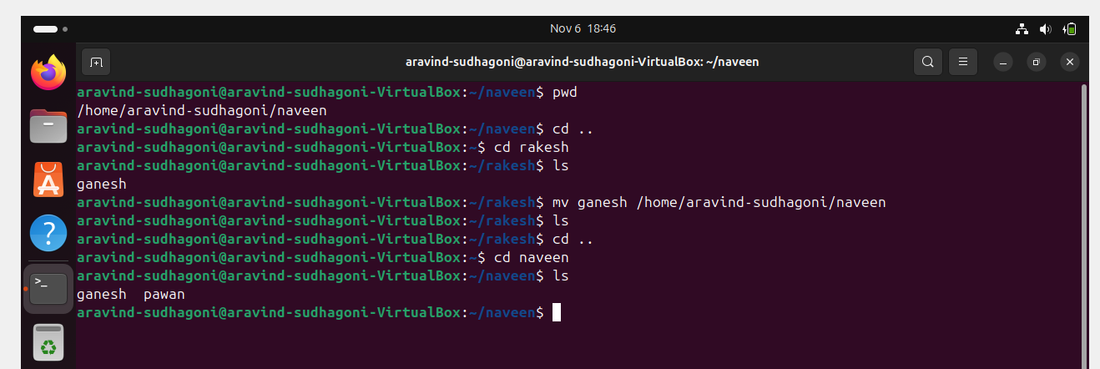

Task 10 Rename a File

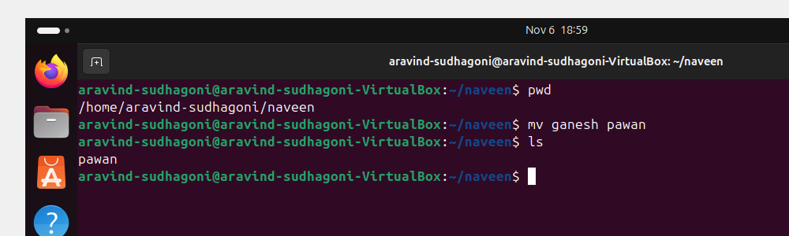

Task 11 Deleate file

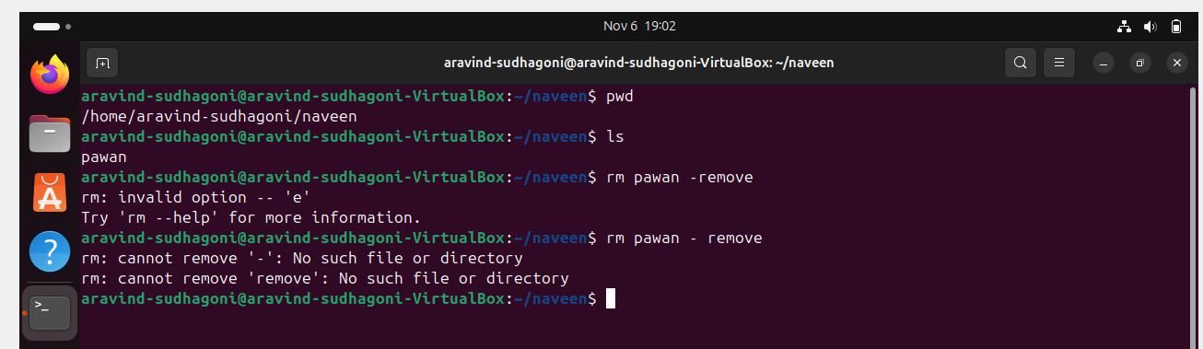

Task 12 Grant or revoke permissions on file or directory

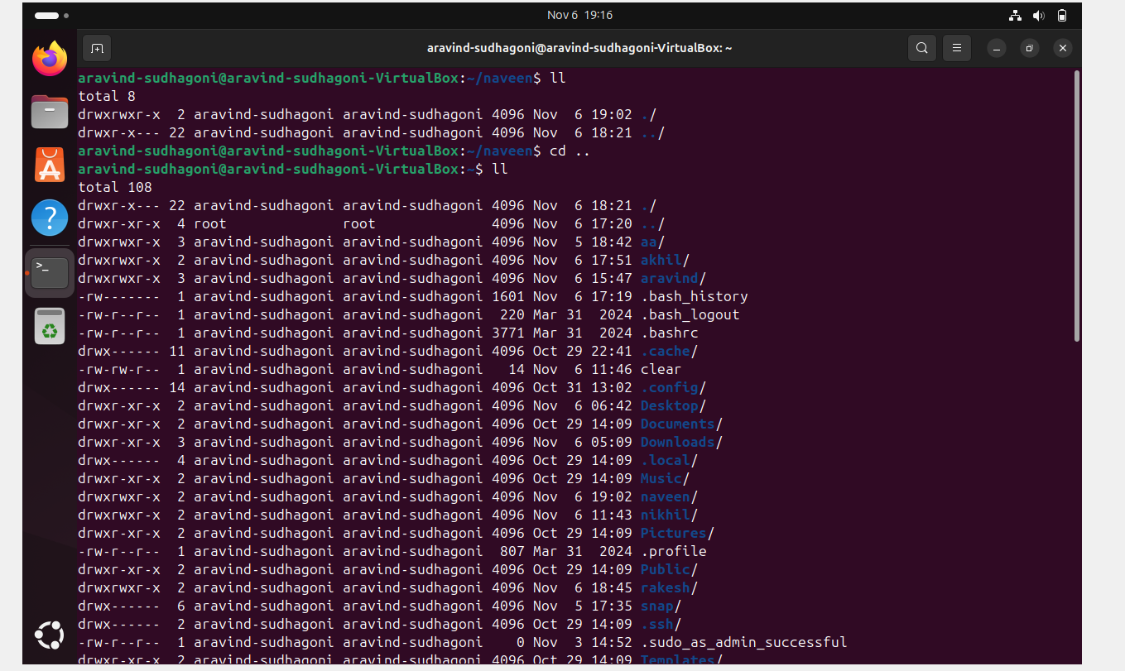

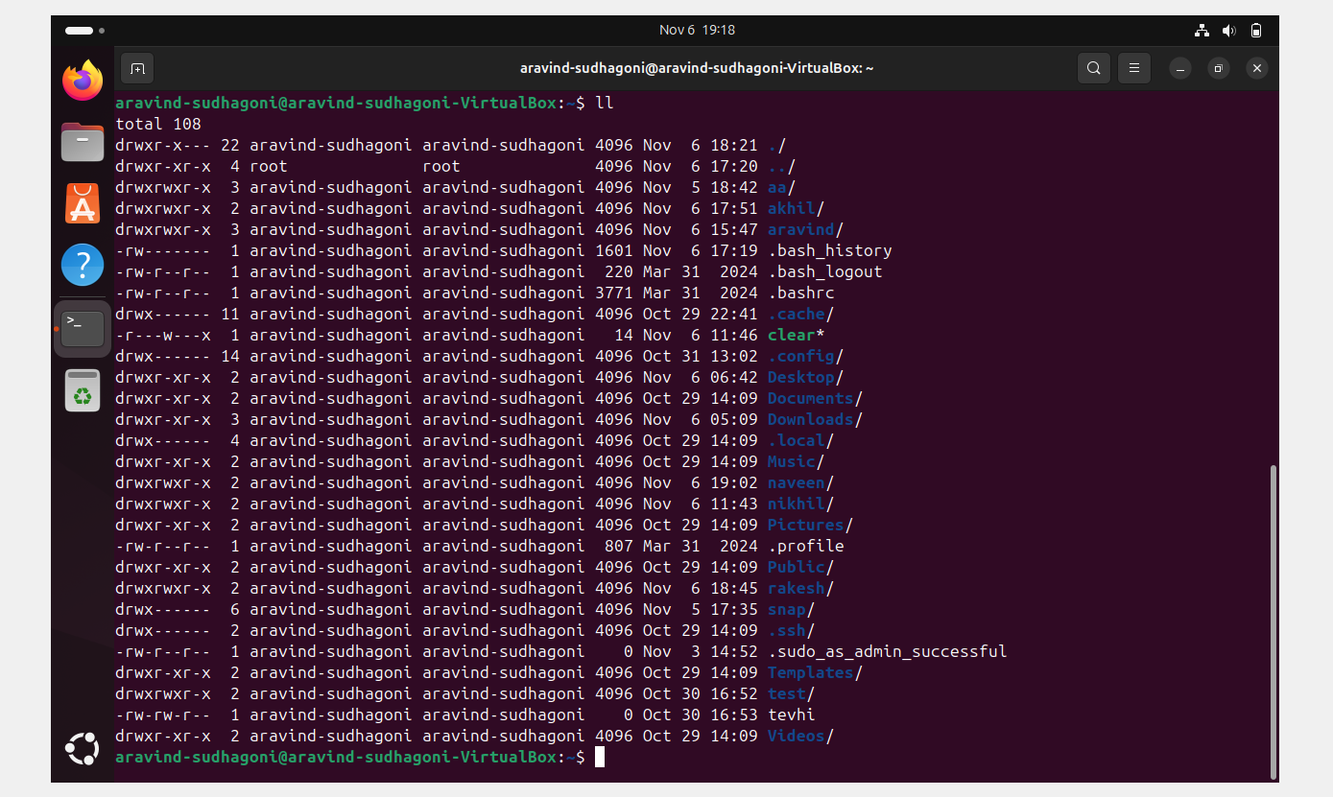

Task 13 view the current date and time

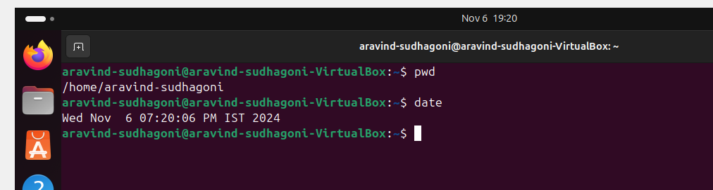

Task 14 check the system time

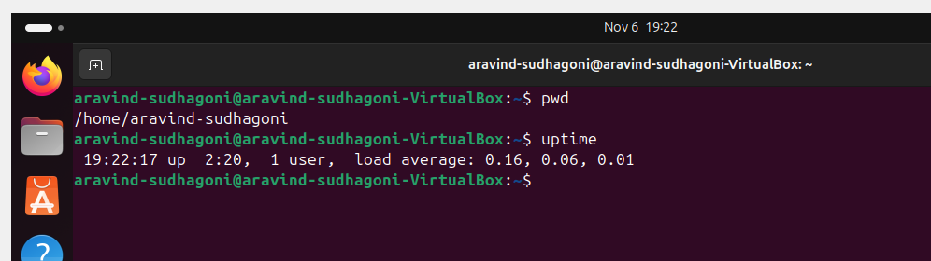

Task 15 view the running process

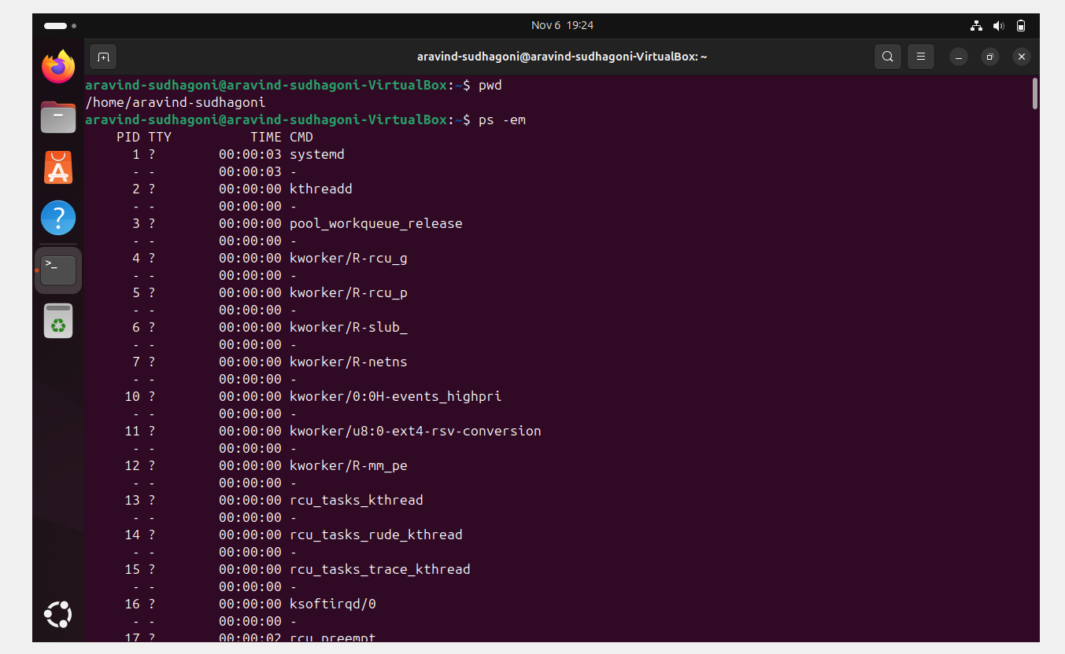

16 kill a running process

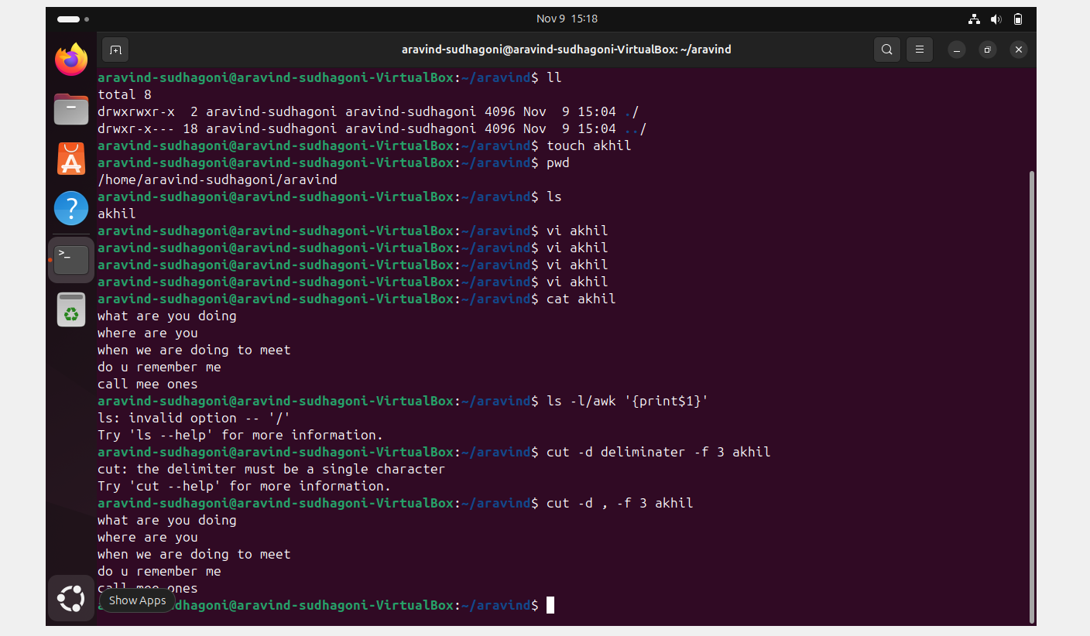

17 Install a running package using the package using apt

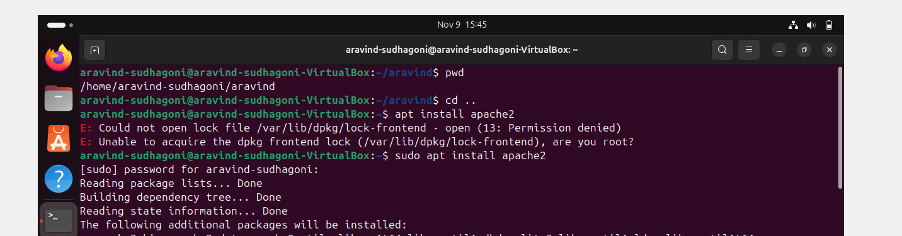

18 update the system packages

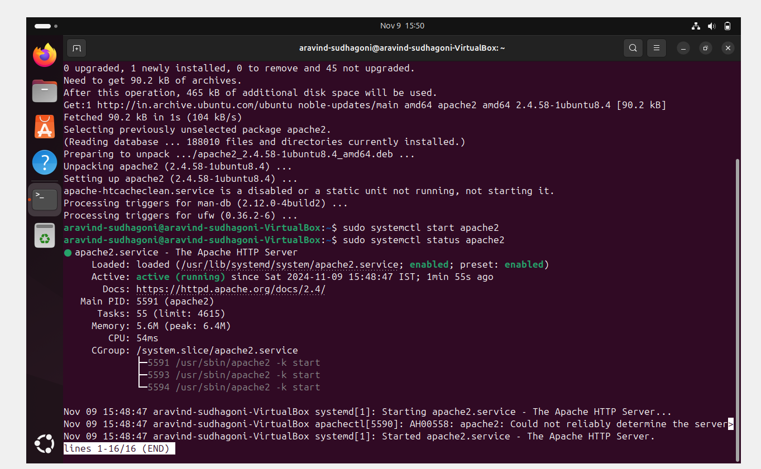

19 create a symbolic link

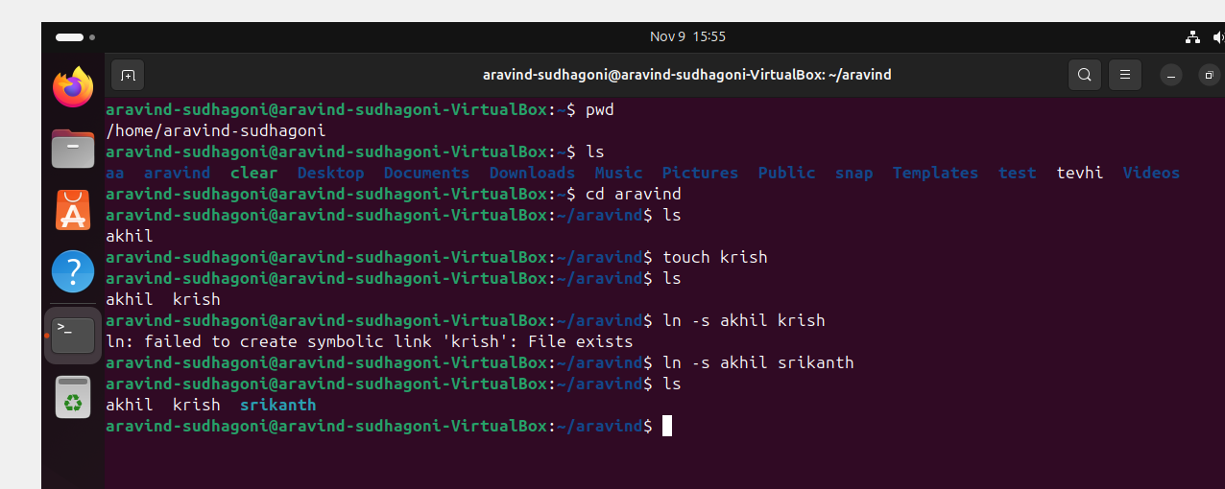

20 search a file using file command

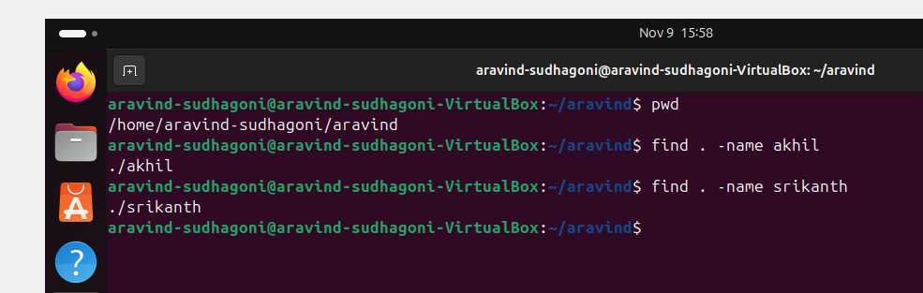

21 compress and decommpres file using tar

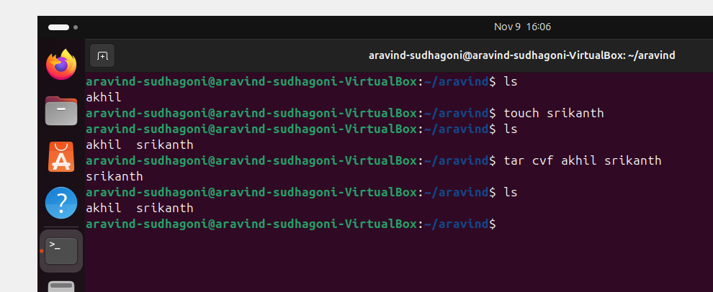

22 moniter system resources with top or htop

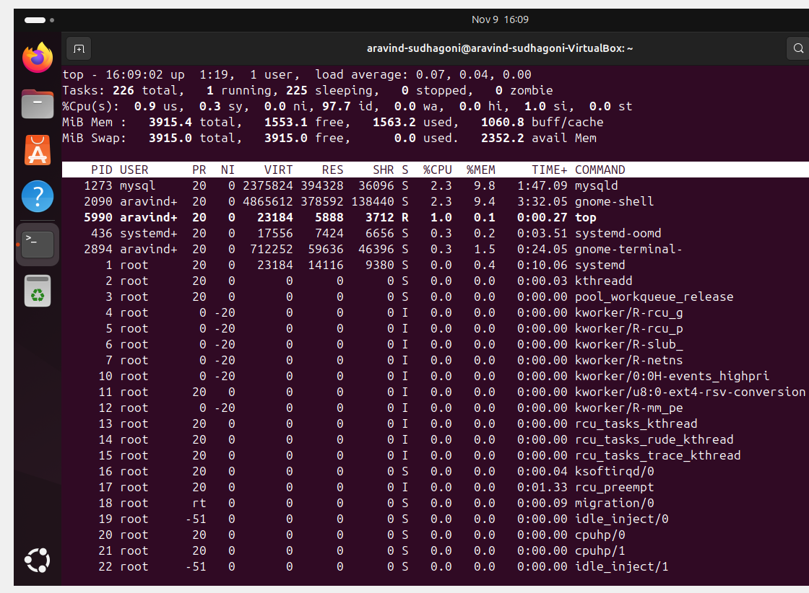

23 creat a mange user groups

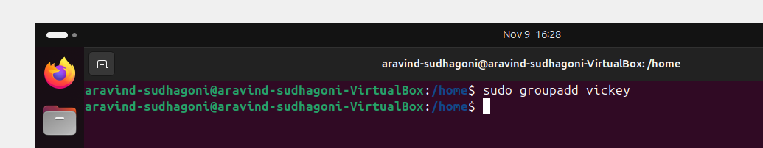

24 set up ssh password less authentication

25 monitor log files using tail

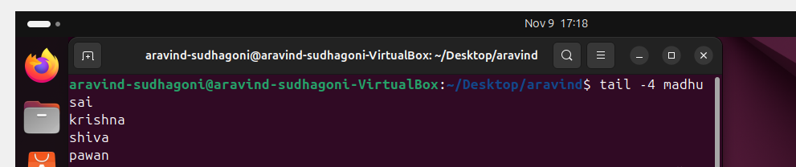

26 set up a web server (eg apache tomcat)

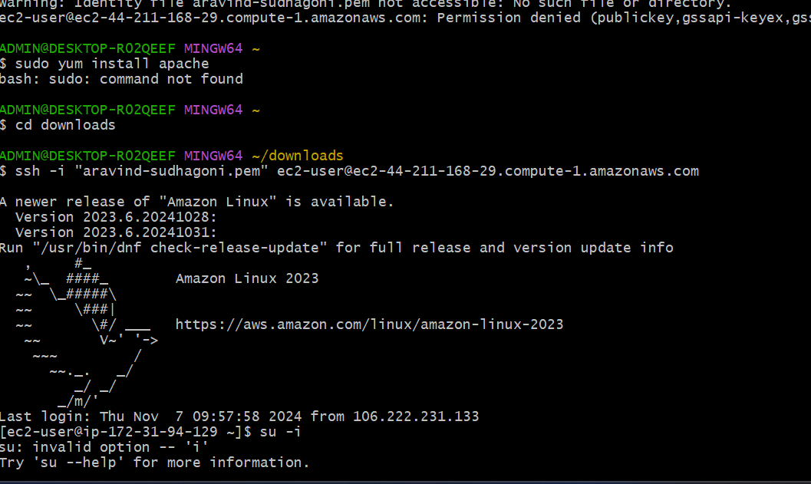

27 configure and secure a mysql database

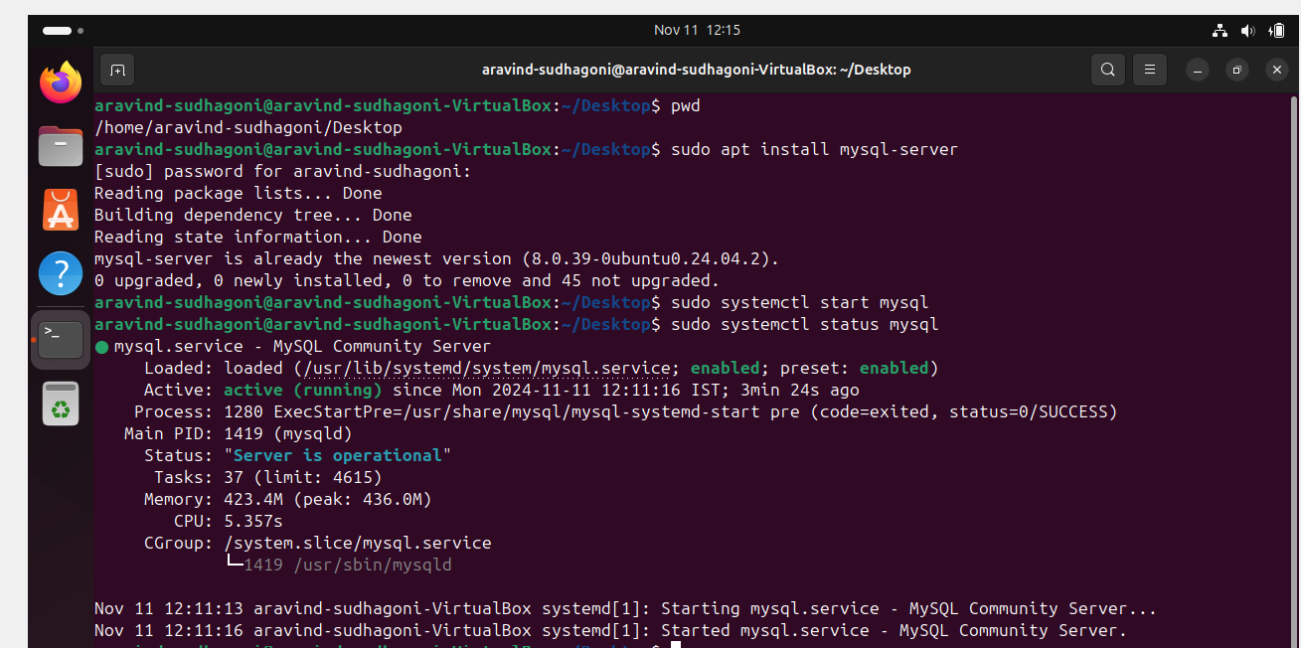

28 set up aapplication server (example apache tomcat)

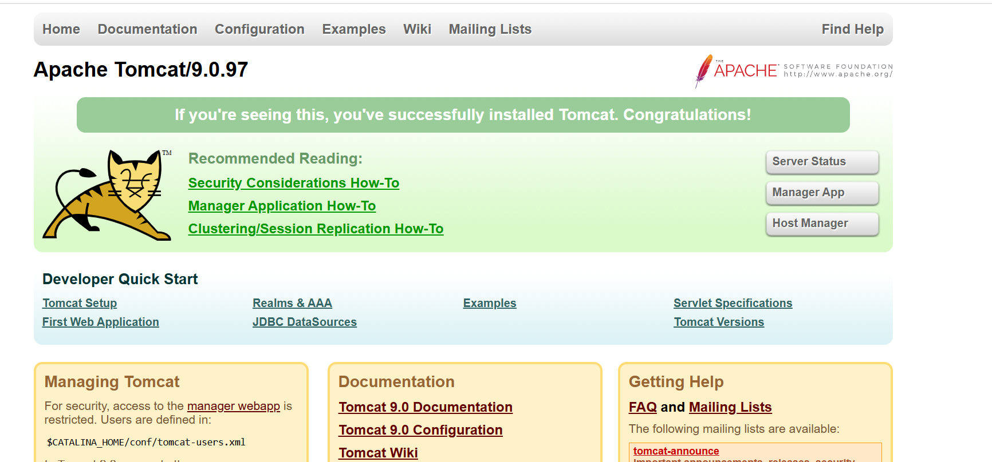

29 create a service file for tom cat

30) print specific column for delimitated file

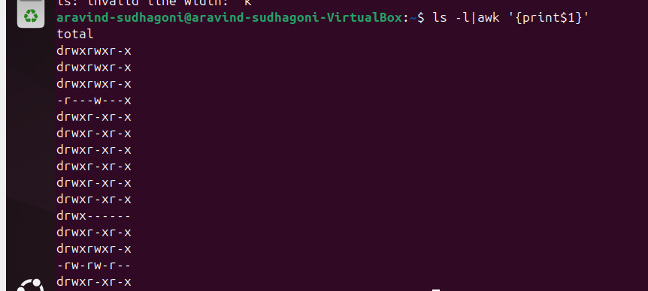

31 filter and printlinesbased on a specific patternor conduction

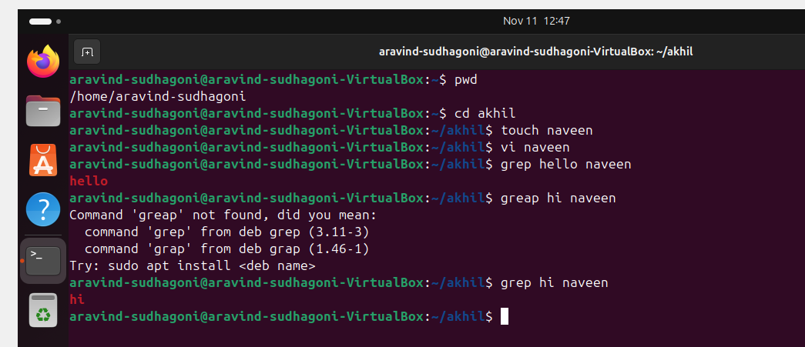

32 caluclate and print the average sum or other statistic of the column

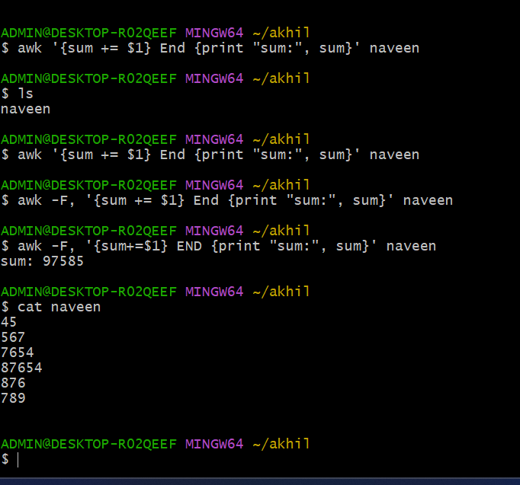

33 perform string manipulations such as extracting sub strings or changing case

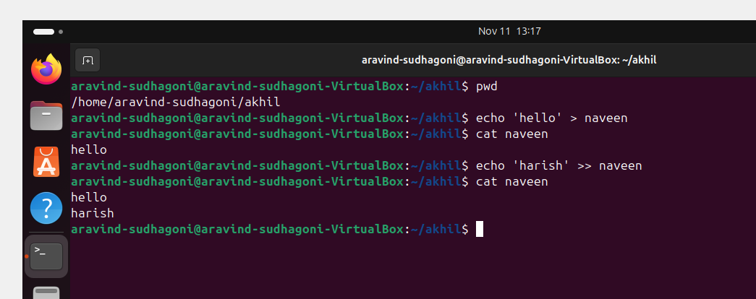

34 count the occurrences of a specific pattern in a file

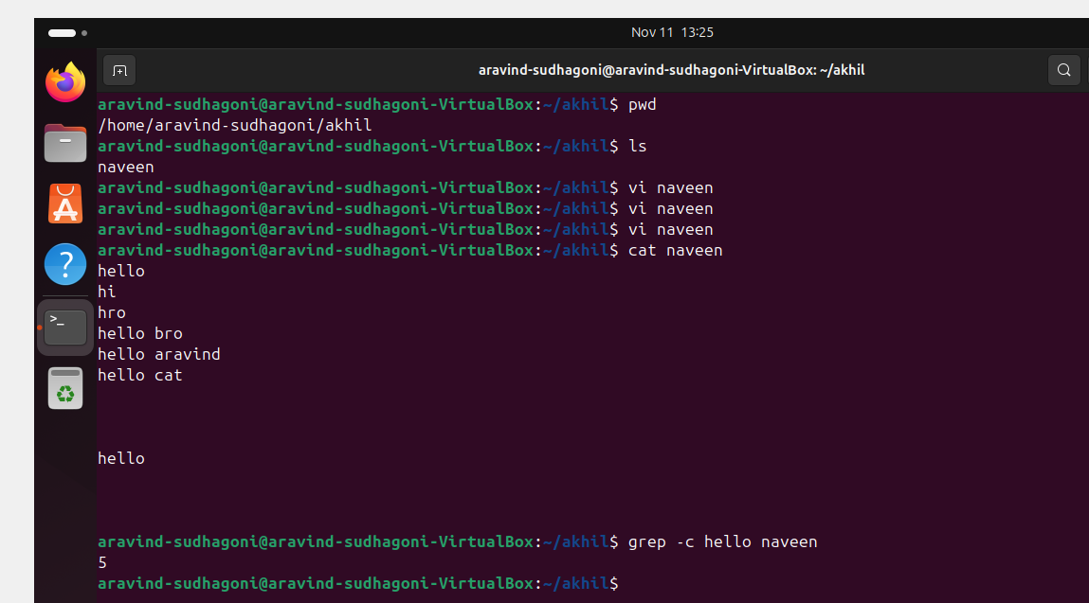

35 sort lines based on a specific field or column

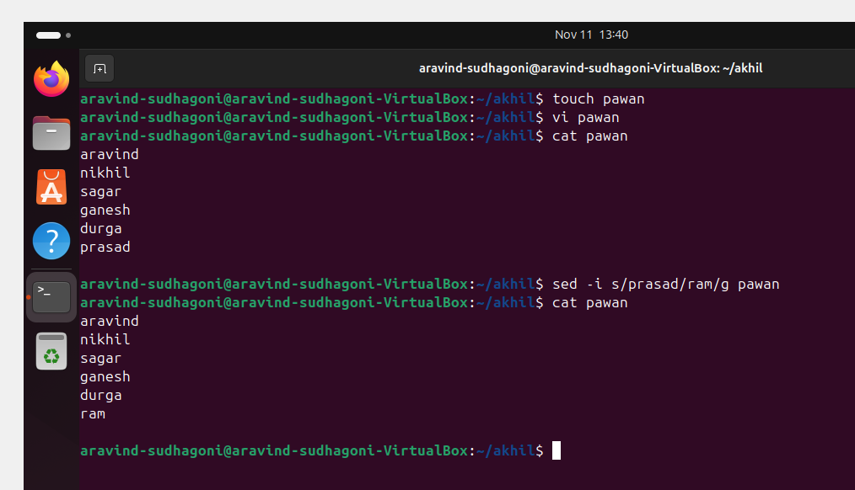

36 merge multiple files based on a common filed or column

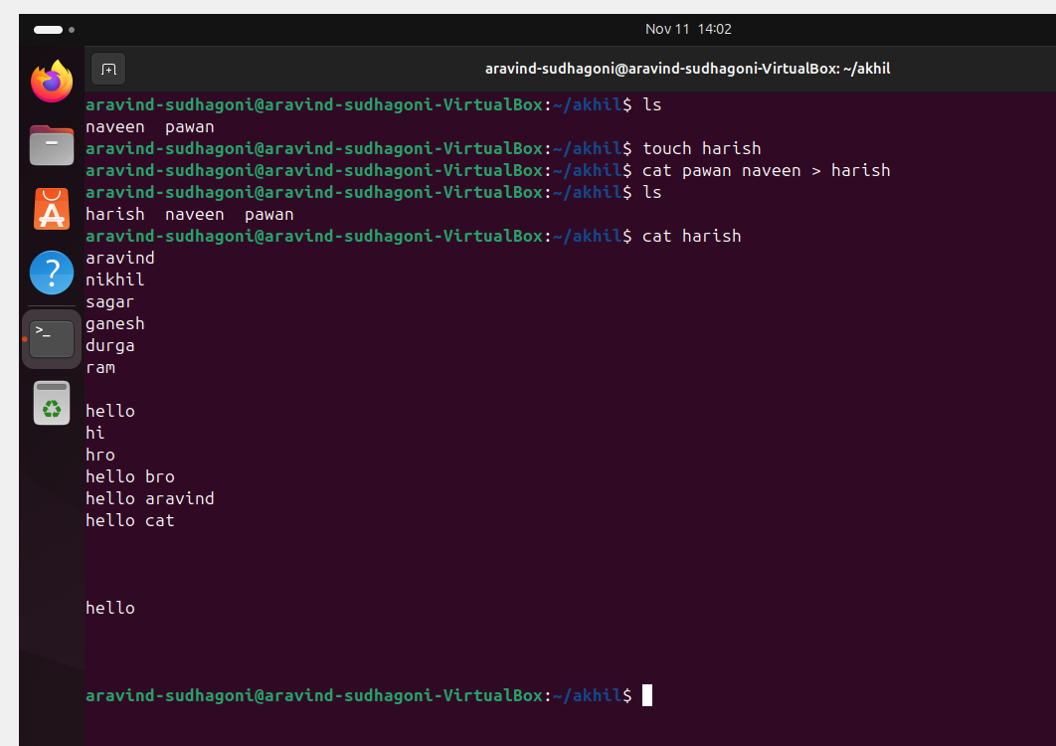

37 substitute text in a file using search and replace

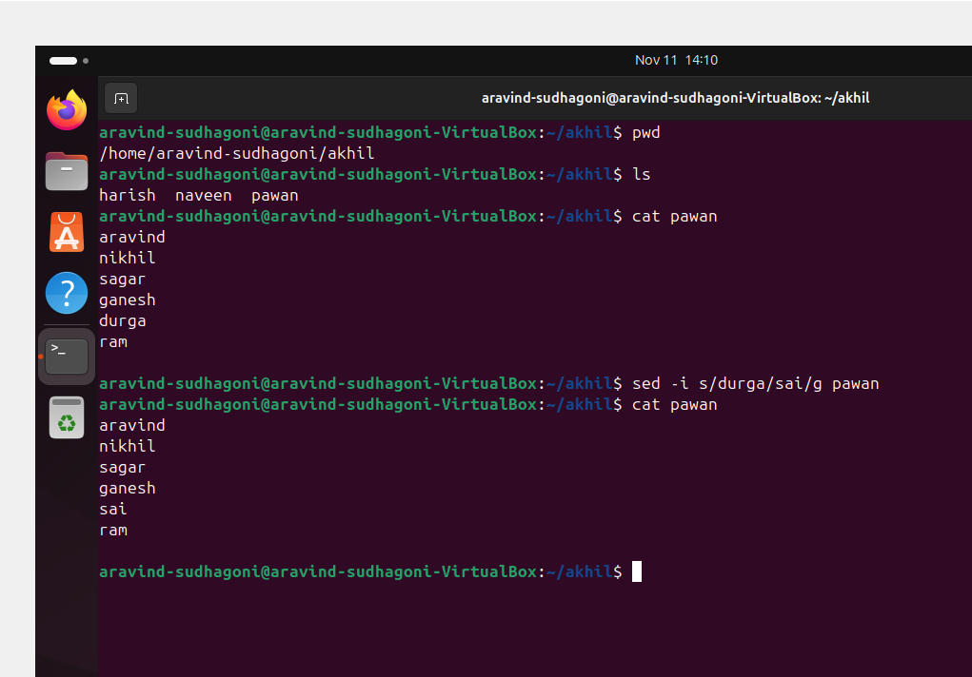

38 delete specific lines based on a pattern or line number

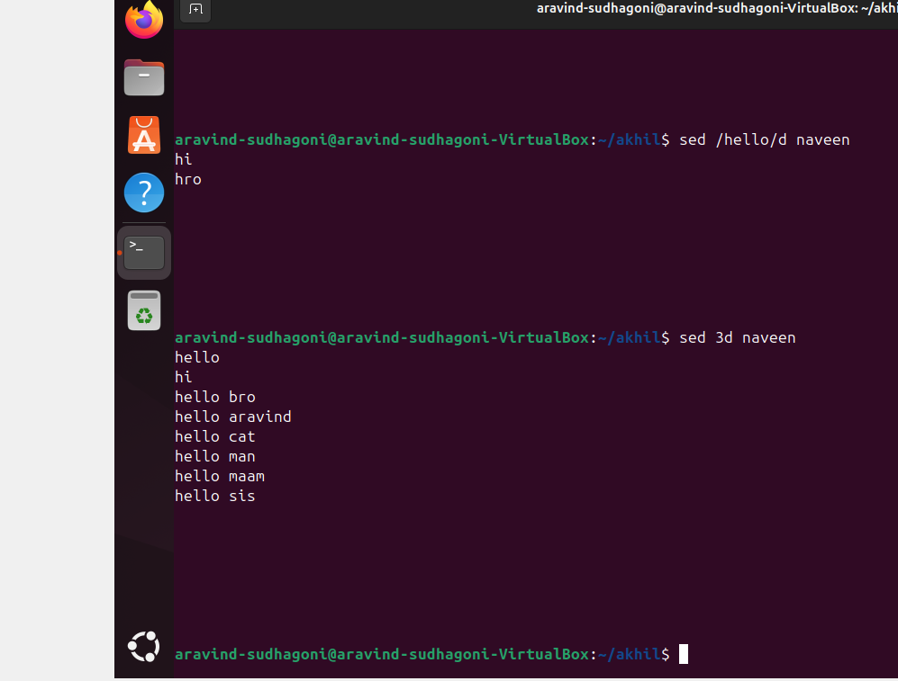

39 append or insert text before or after a specific pattern or line

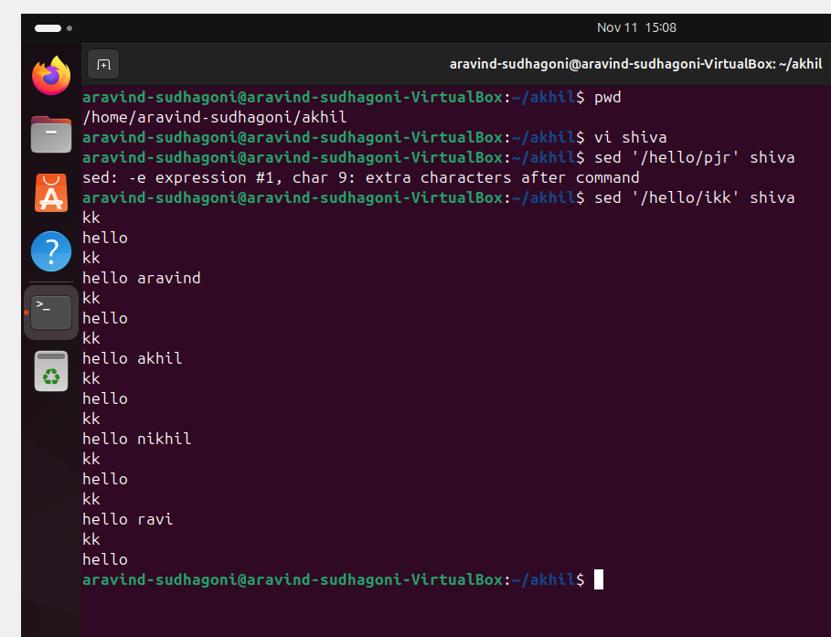

40 print only specific lines from a file

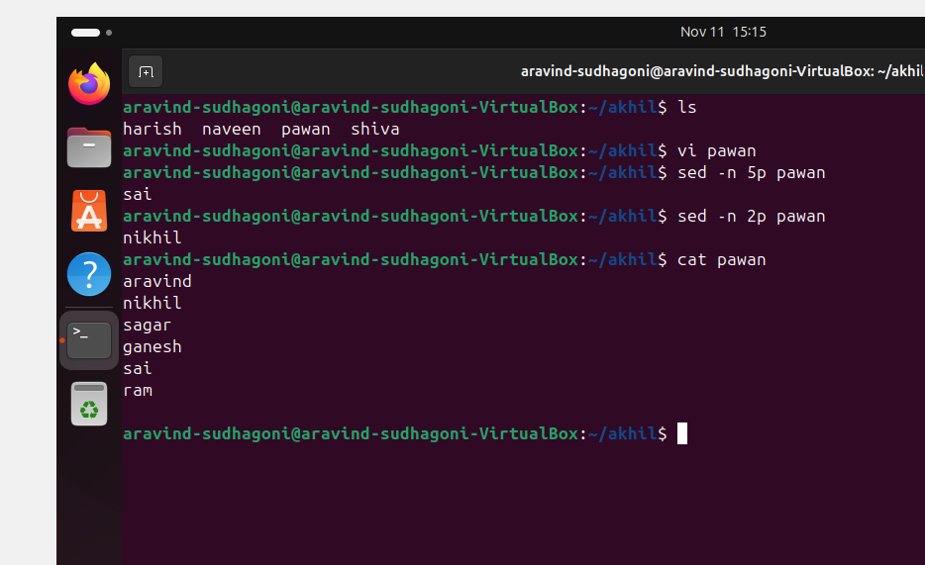

42 5 use cases for Awk and 5 use cases for sed

